 | 19 Editors - Drivers Editor
Table of content
Drivers Editor 3
Time cursor 3
F-Curves 4
Handles 4
Viewport Navigation 4
Viewport navigation 4
Channel Context Menu 5
Frame selected channels 5
Mute Channel 5
Unmute Channel 5
Toggle Protect 5
Protect Channels 5
Unprotect Channels 5
Group Channels 5
Ungroup Channels 5
Toggle Channel Editability 5
Extrapolation Mode submenu 5
Extrapolation Mode 5
Constant Extrapolation 6
Linear Extrapolation 6
Make Cyclic 6
Clear Cyclic 6
Reveal Curves 6
Hide selected Curves 6
Hide unselected Curves 6
Expand Channels 6
Collapse Channels 6
Move submenu 6
Delete Channels 6
Delete Invalid Drivers 6
F-Curve Context Menu 7
Copy 7
Paste 7
Paste Flipped 7
Last operator Paste Keyframes / Flipped 7
Frame Offset 7
Value Offset 7
Type 7
Flipped 7
Handle Type 8
Last Operator Set Keyframe Handle Type 8
Type 8
Interpolation Mode 8
Last Operator Set Keyframe Interpolation 8
Type 8
Easing Mode 8
Last Operator Set Keyframe Easing Type 8
Type 8
Insert Keyframes 8
Duplicate 8
Last Operator Duplicate 9
Mode 9
Values X / Y 9
Axis 9
Orientation 9
Mirror Editing 9
Proportional editing 9
Proportional Falloff 9
Proportional Size 9
Connected 9
Projected(2D) 9
Delete Keyframes 9
Mirror submenu 9
Last Operator Mirror Keys 10
Type 10
Snap submenu 10
Last Operator Snap Keys 10
Type 10
Slider snapping 10
Quick Favorites menu 10
Editing the expression from the property 11
Simple Expressions 11
Variable Names 11
Literals 11
Globals 11
Constants 11
Operators 11
Functions 11
Drivers setup example 12
Control movement of a cube by rotation of a sphere 12
Add input variable 14

Drivers Editor

Drivers are a way to control values or properties by other values or properties. This is done by expressions. As an example, you can use the Y rotation of a sphere to control the X movement of a cube. The rotation of the sphere drives the cube then.

The Drivers Editor is the place to adjust the settings for drivers.

The Drivers editor has several areas.
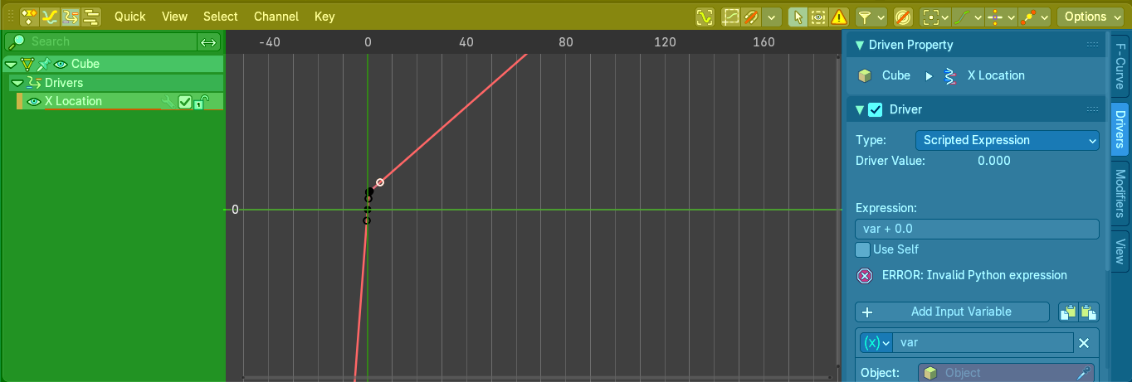
Header ( Yellow )
Channel list ( Green ).
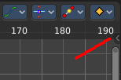
Sidebar ( Blue ). The sidebar needs to be revealed, which can be done by clicking at the small triangle button up right.
Viewport ( no color )
The header is divided into two parts. Left tools and menus. Right Options.
Menus ( Green )
Options ( Yellow )

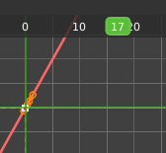
Time cursor
The Time Cursor is the green slider at the top. It is used to set and display the current time frame.

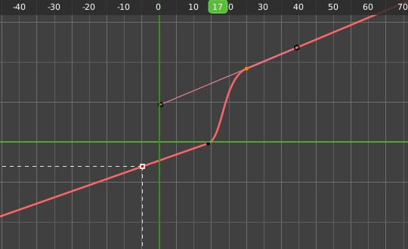
F-Curves
The timeline displays the function curves for the driver. This curve is controlled by the expression. But this curve can also be manipulated in various ways like any other F-Curve. Note that manipulating the curve does not manipulate the expression. It adds on top of it. And there is no way to reset it but create the driver from scratch. So be careful with manipulations.

Handles
Every curve point has handles assigned. The curve can be manipulated by dragging these handlers. You can also change the handle type in the Keyframe Handle Type menu in the header. To make the curve sharp at this keyframe for example.

Viewport Navigation

Navigation in the viewport happens by mouse or hotkeys. Some of them does not have a menu entry. And needs to be explained here.

Viewport navigation
Clicking left at the number bar moves the frame marker.
Middle mouse button pans the view.
Holding ctrl + middle mouse button zooms the view.
Scroll Wheel zooms the view.
To manipulate a curve point, grab one of its handlers and drag.

Channel Context Menu

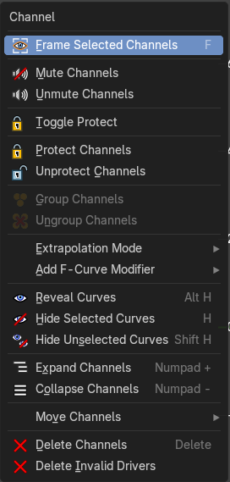
When you right click into the channel area, then you will call the Dope Sheet Channel context menu.

Frame selected channels
Centers the selected channels in view.

Mute Channel
This channel is not calculated.

Unmute Channel
This channel is calculated.

Toggle Protect
Toggle the Protect channels from editing.

Protect Channels
Protect channels from editing.

Unprotect Channels
Enables editing of channels again.

Group Channels
Groups channels together.

Ungroup Channels
Ungroup grouped channels. Beware, the channels will not return to their initial group.

Toggle Channel Editability
Protects or unprotects the selected channels.

Extrapolation Mode submenu

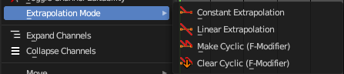
Extrapolation Mode
Sets the extrapolation mode for the selected F-Curves. Means how the curve acts at the beginning and the end of the F-Curve.

Constant Extrapolation
The animation curve continues straight at the end.

Linear Extrapolation
The animation curve continues the last direction.

Make Cyclic
Makes the animation loopable. The interpolation curves are adjusted so that the first frame fits to the last frame.

Clear Cyclic
Removes the cyclic extrapolation.

Reveal Curves
Reveal all curves.

Hide selected Curves
Hides the selected curves.

Hide unselected Curves
Hides the unselected curves.

Expand Channels
Expands the channels.

Collapse Channels
Collapses the channels.

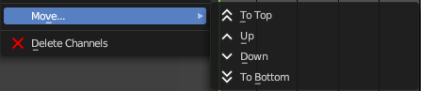
Move submenu
Sort the order of the channels. The menu items should be self explaining.

Delete Channels
Removes the selected channels.

Delete Invalid Drivers
Deletes Invalid Drivers.

F-Curve Context Menu
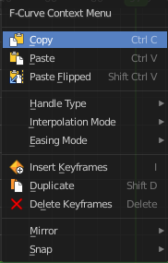
When you double right click into the viewport then you will call the F-Curve context menu.

Copy
Copies the currently selected curve point(s).

Paste
Pastes copied curve point(s)

Paste Flipped
Pastes copied curve point(s), but flipped.

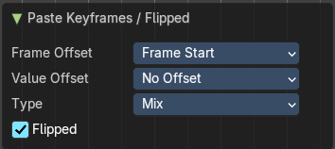
Last operator Paste Keyframes / Flipped

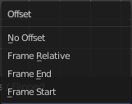
Frame Offset
Define a time offset to paste the keys.

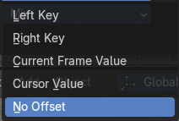
Value Offset
Define a value offset to paste the keys.

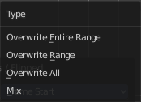
Type
The paste method.

Flipped
Paste copied curve point(s) flipped.

Handle Type
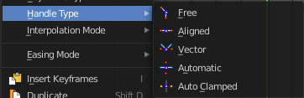
Set the handle type for the currently selected curve point.
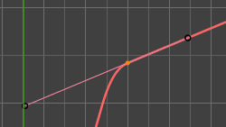

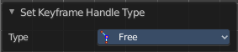
Last Operator Set Keyframe Handle Type

Type
Set the handle type for the currently selected curve point.

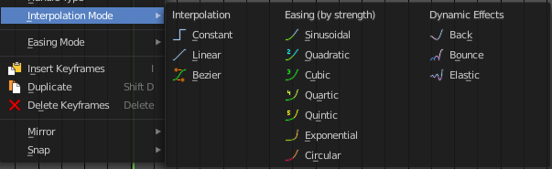
Interpolation Mode
The Interpolation mode defines how the curve acts from keyframe to keyframe. You can have a linear curve between two keyframes instead of a bent one for example.
The easing methods here in the interpolation mode menu are for the easing shape. There is also an easing menu where you can choose a easing method.

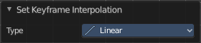
Last Operator Set Keyframe Interpolation

Type
Set the interpolation mode.

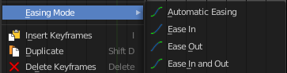
Easing Mode
The easing methods in the interpolation mode menu are for the easing shape. This menu allows you to choose an easing method.

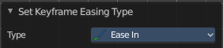
Last Operator Set Keyframe Easing Type

Type
Set the easing type.

Insert Keyframes
Insert a keyframe at the current position. This functionality does not work from the Drivers editor.

Duplicate
Duplicate the selected curve point(s).

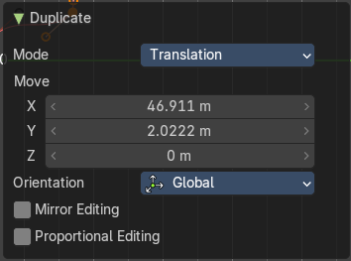
Last Operator Duplicate

Mode

Values X / Y
The x and y values for the pasted keyframes. Note that these values starts at the position of the original copied keyframe. These values are relative.
Values Z and W have no effect here.

Axis
These values have no effect.

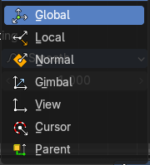
Orientation
These values have no effect.

Mirror Editing
Enable Mirror Editing.

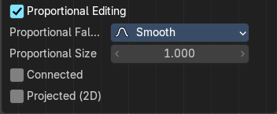
Proportional editing
Enables proportional editing. Activating proportional editing reveals further settings.

Proportional Falloff
Adjust the falloff methods.

Proportional Size
See and adjust the falloff radius.

Connected
The proportional falloff gets calculated for connected parts only.

Projected(2D)
The proportional falloff gets calculated in the screen space. Depth doesn't play a role. When it's in the radius, then it gets calculated.

Delete Keyframes
Delete the selected curve point(s).

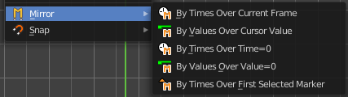
Mirror submenu
Mirrors the animation by the given method.

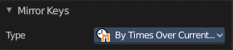
Last Operator Mirror Keys

Type
Flips the selected keyframes over the current frame position by the chosen method.

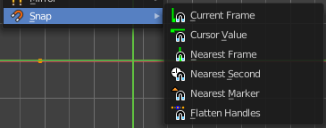
Snap submenu
Snaps the selected keyframes by the given method.

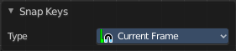
Last Operator Snap Keys

Type
Snaps the selected keyframes by the chosen method.

Slider snapping
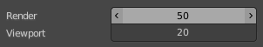
Snapping also works at sliders. Hover with the mouse over the slider, start to slide, and holding down Ctrl will snap the sliders in incremental steps.
When it's a default value between 0 and 1 then it usually snaps in 0.1 steps. When it's a default value over 1 then it usually snaps in steps of 10.
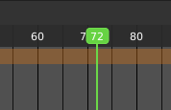
The increment snapping also works at the frame slider. Here the incremental snapping happens by the frame rate that you have defined. With a frame rate of 24 it will snap in steps of 24 frames when holding down ctrl.

Quick Favorites menu


When you right click at a menu or a button, then a right click menu will open. Tools have usually a Add to Quick Favorites menu entry.

The Quick Menu is empty by default. With Add to Quick favorites you can add this menu to the Quick menu.

In the 3D view we have a menu called Quick in the header, which shows this content then. In the Dope Sheet Editor you can just call it with its hotkey. Q. It has no regular menu entry here.

Editing the expression from the property
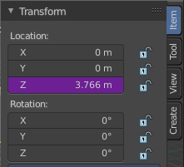
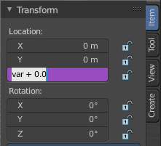
A property with a driver attached will turn pink.
When you click into the edit box, then the expression for the driver will appear. And you can edit this expression now without to edit the driver again.

Simple Expressions

There are some advanced expression methods, called Simple Expressions.

Variable Names
Use only ASCII characters.

Literals
Floating point and decimal integer.

Globals
frame

Constants
pi, True, False

Operators
+, -, *, /, ==, !=, <, <=, >, >=, and, or, not, conditional operator/ ternary if

Functions
min, max, radians, degrees, abs, fabs, floor, ceil, trunc, int, sin, cos, tan, asin, acos, atan, atan2, exp, log, sqrt, pow, fmod

Simple expressions are evaluated even when Python script execution is disabled.

When an expression outside of this subset is used, Blender displays a “Slow Python expression” warning. However, as long as the majority of drivers use simple expressions, using a complex expression in select few is OK.

Drivers setup example

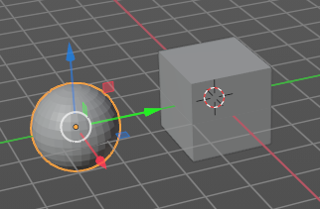
Control movement of a cube by rotation of a sphere
Create a cube and a sphere, and place the sphere a bit off. We want to be able to select and modify it.

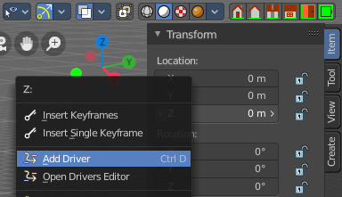
Select the cube.
In the Transform panel in the sidebar right click at the Z value and choose Add Driver. We will add the driver to the Z axis property of the cube.

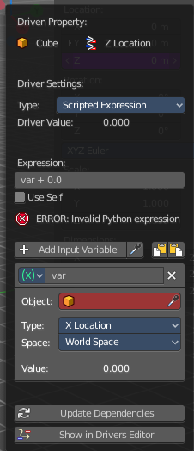
When you add a driver a panel will pop up where you can do the drivers setup.

In case you miss this panel by too fast clicking, it can be called again by right clicking at the property again and choose Edit Drivers from the menu.

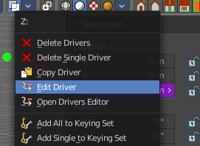

Don't worry about the ERROR: invalid Python expression at this point. we are going to change this now.

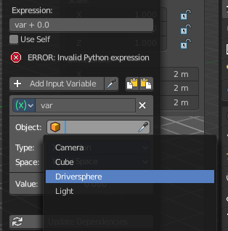
In the red field with the Object label choose the sphere.

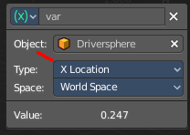
By default the X value influences now the Z position of the cube. So when you move the sphere in X direction, the cube will move in Z direction.

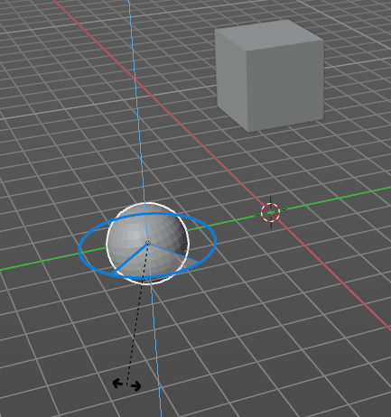
Let's change this to rotation around Z axis. Now the cube moves in Z axis when we rotate our sphere in Z axis.

Let's have a look into our Drivers editor.
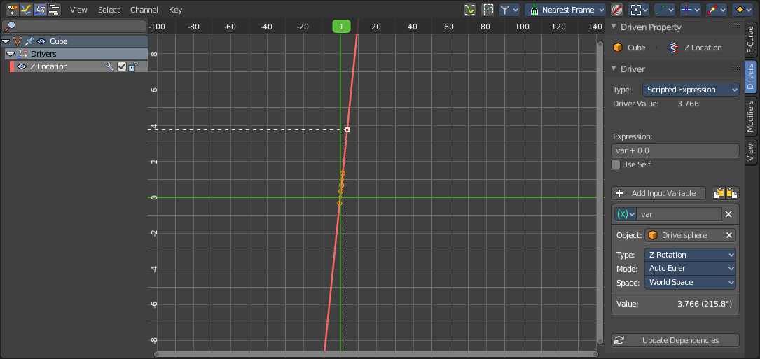
We have now content available- The channels list has an entry. And when you click at the Z Location channel in the channel list then the content and the driver settings panel in the sidebar will appear. It is the same than the one from the right click menu.

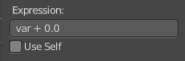
Let's have a closer look at how this all works. The Expression field is the place where the magic happens. When you change this expression then you can change the behavior of the driver. For example instead of var + 0.0 you could add a multiplicator here to our variable called var. Let's say var *2. Then the cube moves in double speed of the rotation of our sphere.

Add input variable
You could also add a second input value, and connect it with another object. Let's say a cone.

Add a cone object.

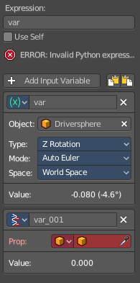
In the Driver add a new input variable.

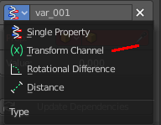
Change this input variable to type Transform Channel.

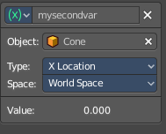
Now in the object field choose our cone object. And rename the input variable to something meaningful. Again set the type to your needs.

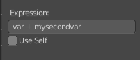
Now let's change the Expression to this: var + mysecondvar.

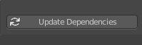
As a last step update the dependencies by clicking at the Update Dependencies button at the end, which will remove the Invalid Python Expression error.

And now the driver is controlled by the Z rotation of our sphere, which is defined in the variable var. PLUS the x location of the cone object, which is defined in the variable mysecondvar.

